Powering IoT Sensor Networks with Harvested Energy from Trees

Nick T. Purcell¹, James D. Stevens², Graham Boyer³, Eric J. Carlson4, Eric D. Pospisil5

University of Washington Tacoma, Washington  
Department of Electrical Engineering

João Pessoa, Brazil

[ntp117¹, jamesssf², gboyer253³, e24, epos335]@uw.edu

Orlando R. Baiocchi

University of Washington at Tacoma, UTW   
Institute of Technology

Tacoma, WA USA

baiocchi@uw.edu

***ABSTRACT:*  With the coming advent of smart devices, remote monitoring and long-range radio communication, there has been an increasing interest in alternative power sources and energy harvesting techniques to prolong indefinitely the smart devices life. One of these alternatives is to take advantage of the Seebeck effect, a natural occurring phenomenon by which the temperature difference between two different types of conductive materials produces a slight voltage difference between them. By leveraging the thermal difference between the core and the surface of a tree trunk to power an IoT device we define the tree as a “smart tree”. When two or more trees are connected to other clusters of trees in an area with radio communication, a “smart forest” will be defined. This paper discusses the design process that uses XBEE RF modules for communication and thermoelectric generators (TEGs) in the energy-harvesting module. It shows how the devices and the network are implemented in the field, as well as the discrete components designed for harvesting energy from a tree. The trees and techniques were chosen to build up enough current and voltage to power the system. It also shows the proposed solution for the transition from a smart tree to a smart forest while allowing for remote monitoring.**

**Keywords: Wireless Sensor Networks, Energy Harvesting, Tree Trunks, Peltier Cell, Seebeck Effect.**

1. Introduction

    Modern Wireless Sensor Networks (WSNs) provide data and analytics for safety, efficiency, and other means of monitoring. These sensors require a range of voltages to operate and are normally powered by conventional means such as the power grid or batteries. Sensors must also be connected to a host device which handles the data and communications. The host devices usually require between 3.7 and 5 volts.

The purpose of this study is to develop an ecologically friendly way of powering environmental sensors in remote forest regions. Using previous research on the temperature gradient between the core of tree and its outside ambient temperature it is possible to extract energy from tree trunks using the Seebeck effect (Protosio 2019).

The remainder of this paper is organized as follows: Section 2 introduces the Experimental Energy Harvesting system and thermoelectric generation in details. Section 3 presents the Experimental WSN hardware and protocols. Section 4 shows experimental results. Section 5 concludes the paper and gives possible future directions.

1. Energy Harvesting System

Energy Harvesting is defined as the practice of capture, accumulation and storage of energy from surrounding environmental sources (Santos, 2014) (Wu, 2014) (Moraes Junior, 2013) (Ramadass, 2011) (Harb, 2011)(Galayko, 2007) where the energy source can be one or a combination of the available sources such as solar, light, temperature, motion or electromagnetic waves.

Energy harvesting devices are potentially attractive as alternatives for batteries in low power wireless sensor nodes or to prolong battery life by charging rechargeable batteries (Ismail, 2009).

Figure 1 presents a basic architecture of an energy harvesting based sensor node. The main components of the energy harvesting part are: (I) the energy transducer, (II) the energy management circuit and (III) optional storage devices as batteries or supercapacitors. The energy transducer performs the conversion of a primary energy source (like solar, thermal, mechanical vibration, etc.) to electrical energy and the energy management circuit carry out voltage rectification, conversion, regulation, etc.

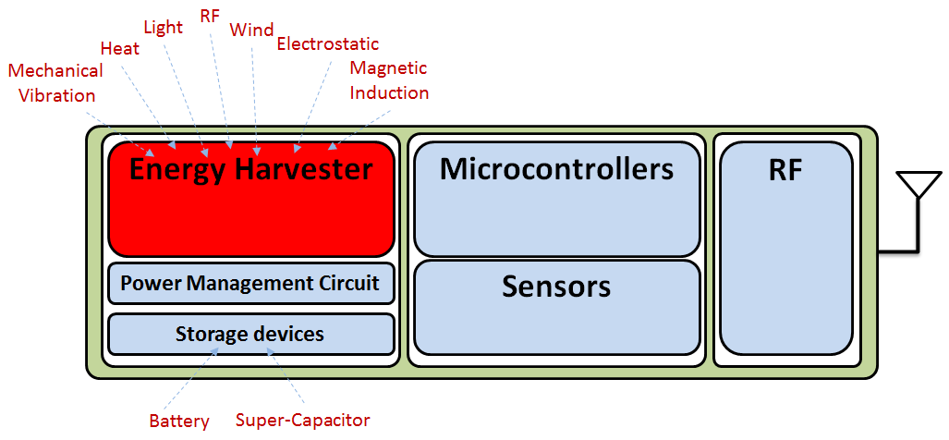

Figure 1. Basic architecture of an energy-harvesting based sensor node.

In the next section, we will focus on some explanation about the behavior of tree internal temperature and the basic idea to harvest energy from a tree trunk.

1. Behavior of tree internal temperature

Under the tree bark is a living organism full of life-giving processes hidden from human view, and one of these processes is the ability of trees to absorb water and mineral nutrients from the soil and to collect carbon dioxide and solar energy with its leaves (Harmon, 2007). As a consequence, tree trunks can store considerable amounts of energy in the form of heat where the correspondent heat storage rate (e.g., in J s−1, or W) can be represented as follows:

heat storage rate =CpVTt         (1)

where Cp is the volumetric heat capacity (e.g., in J m−3 ◦C−1 and indicates the amount of heat required to raise the temperature of unit volume by 1◦C.), and V is the volume that undergoes a change in temperature *T* in the time interval *t* (Nobel, 2009).

    In this way, according to the tree trunk dimensions and its species, its heat storage can be potentially important for obtaining different temperature gradients, since the tree trunk can be divided into isothermal sub volumes, which are generally referred to as annual rings as it is shown in Figure 2.

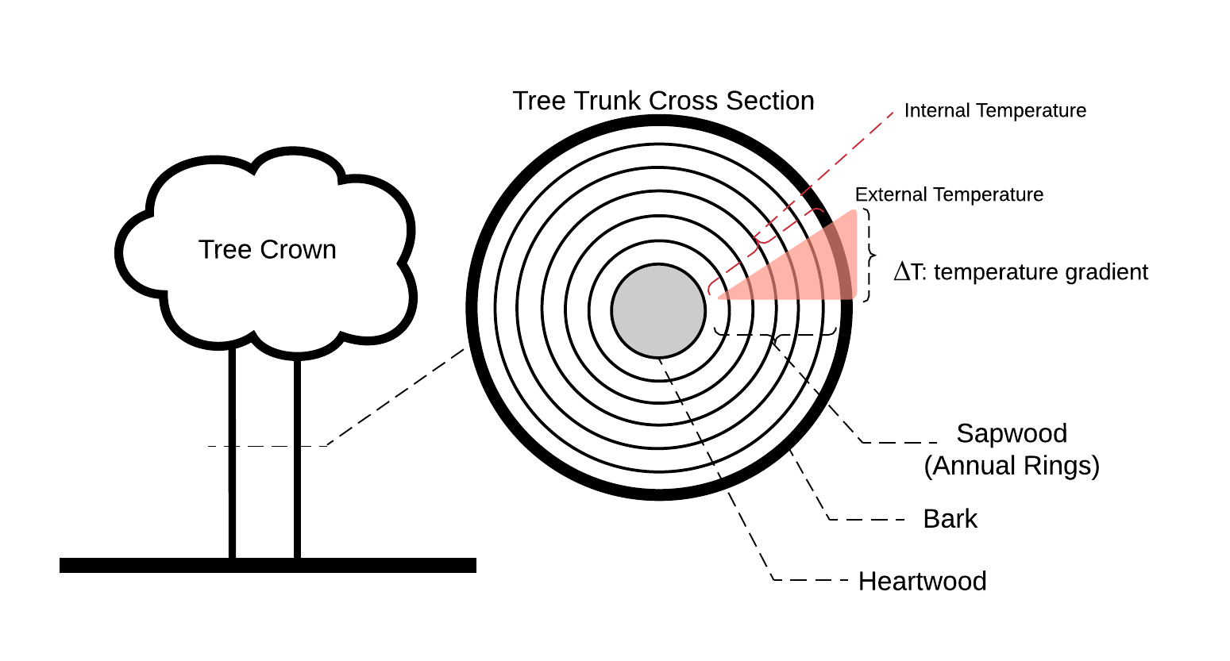

Figure 2. Tree Trunk Cross Section (Nobel, 2009).

As described, a tree trunk is a living organism and in conjunction with its heat storage characteristic, as shown in Eq. (1), it is believed that the temperature gradient between any annual ring and the external temperature can be slightly constant or presents slow increment or decrement as the external temperature varies. Additionally,  it is supposed that the tree tries to remain in a comfort zone despite its external temperature as demonstrated in Helliker (2008) that indicated that tree leaves regulate its temperature to around 21.4° Celsius during photosynthesis.

With this assumption, it is straightforward to consider the temperature gradient of trees in order to generate energy taking a well-known transductor of temperature to electrical voltage, the Peltier cell.

* 1. Peltier Cell

Thermoelectric module can operate either as an electrical generator or as a cooling/heating device since it is used for conversion between thermal and electrical energy and vice-versa (Harb, 2011) (Priya, 2009) (Ismail, 2009) (Tan, 2011) (McPherson, 2010). A thermoelectric module consists of an array of p- and n-type semiconductor based thermocouples placed between two ceramic plates, as shown in Fig. 3, where these thermocouples are connected electrically in series and thermally in parallel.

When working as electrical generator, a thermoelectric module is denominated a thermoelectric generator (TEG), or a Peltier cell, and the generated electric energy is proportional to the temperature gradient on its faces. Typically, commercial modules are made of Bi2Te3-alloys (Barako, 2012).

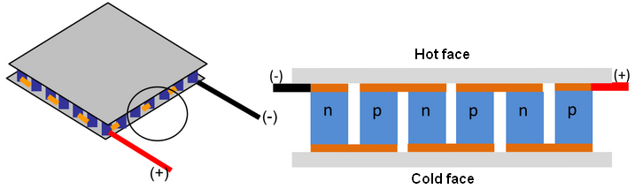

Figure 3. Thermoelectric Module and its internal structure (Source: Nesarajah, 2014).

In general, applying a temperature gradient T on the hot and cold faces of a Peltier cell, a voltage is generated in its terminals. Commercial modules already produce electrical energy from Taps low as 2ºC.

In the next section, we will describe the implemented WSN and the procedures to measure internal and external temperature of tree trunk under field conditions.

1. Proposed WSN to measure tree trunk temperature

In order to measure the internal and external temperature of tree trunk and its variation in a specific period of time, a WSN was set in a star topology consisting of two sensor nodes installed on two trees and a sink node connected to a base station (a PC computer in a laboratory), as shown in Figure 4, which was made using the INSITE© simulation program (REMCOM, 2015) (Silva,2015).

This WSN was implanted at the parking lot of the Center of Technology at Federal University of Paraíba - Brazil and the sensors are installed into trees which specie is *Adenanthera pavonina*, commonly called Red Lucky Seed that is medium-sized to large deciduous tree, 6-15m tall and up to 45 cm diameter depending on its location (Adkins,1996).

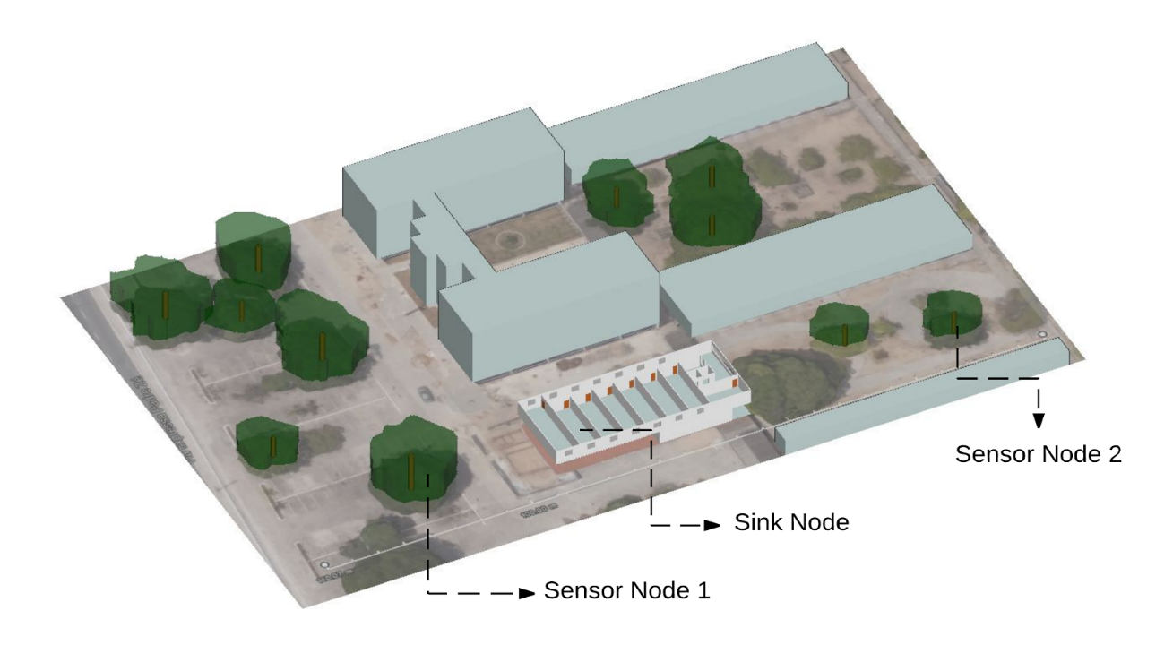

Figure 4.  Developed WSN for tree’s temperature monitoring.

The sensor nodes are based on the Namimote, shown in Figure 5, which is a wireless sensor node that aims to provide a low cost and multi-purpose sensor node platform for wireless sensor networks (Müller, 2012) and is developed by the Namitec project (INCT Namitec, http://namitec.cti.gov.br), as a part of an investment from Brazilian government. The Namimote is comprised of a microcontroller unit (MCU), which has an embedded IEEE 802.15.4 transceiver, and three onboard sensors: luminosity, temperature and three-axis accelerometer, as can be seen in Figure 6. Additionally, Namimote presents a general purpose input/output (GPIO) with digital and analog for any type of expansion and its RF port feeds a power amplifier (PA) to provide long range links (Müller, 2012).

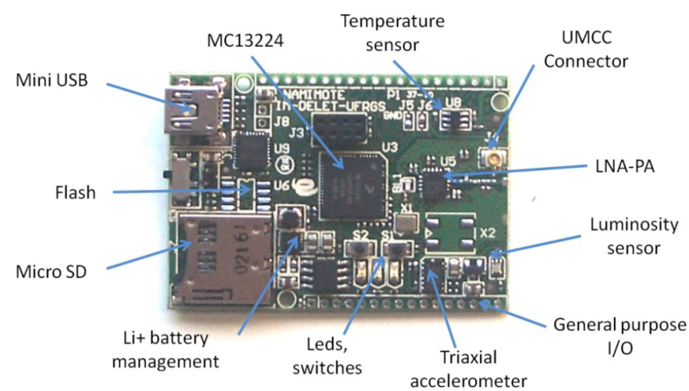

Figure 5.  Namimote  (Müller, 2012).

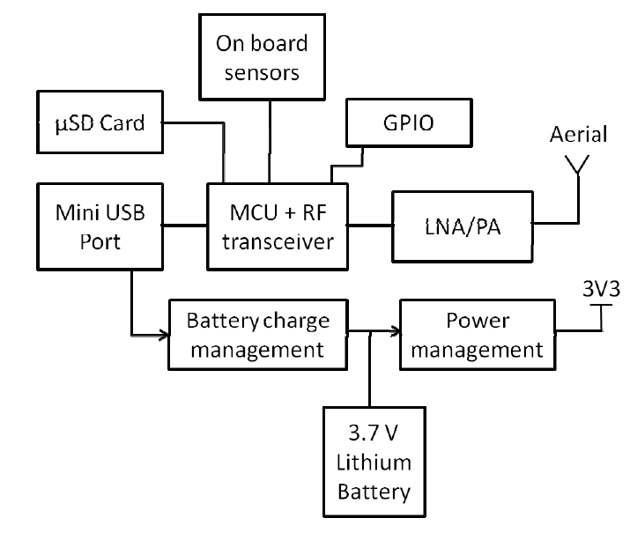

Figure 6. Block diagram of Namimote sensor node.

As the main objective of this work is the measure of the temperature gradient T between internal temperature at different depth (or different annual ring) and the external temperature, it was decided to measure three internal points using the TMP36G from Analog Devices as temperature sensor, since it is a sensor compatible with the 3.0V Namimote's power supply.

The two sensor nodes are shown in Figure 7, where each was mounted into a plastic case and composed of an external antenna and the three temperature sensors that were mounted in a measurement stick.  Each measurement stick is a PCB of different length where in an end the TMP36G integrated circuit was welded, as shown in Figure 8. The temperature measurement sticks are of three different lengths: 100mm, 75mm, and 50mm.

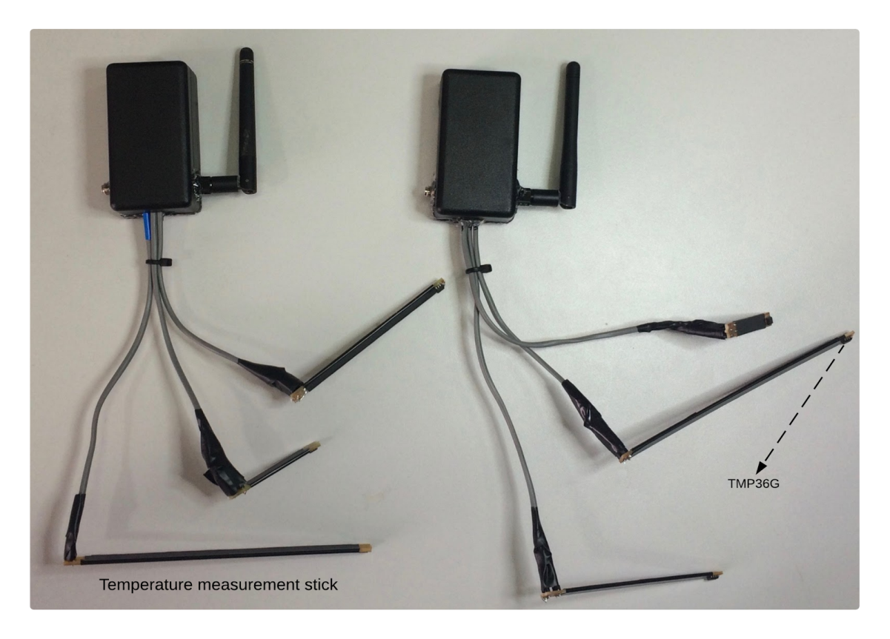

Figure 7. Namimote based sensor node cases.

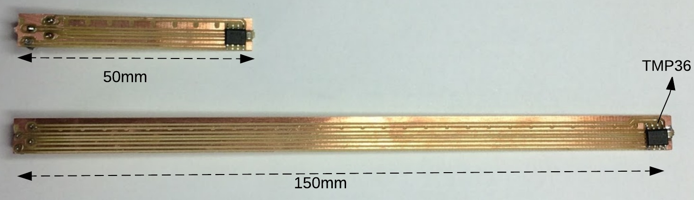

Figure 8. Temperature measurement stick.

The sensors were calibrated in order to minimize the error during the measurements. The next step was drilling the trees. As shown in the Figure 9, three holes were made with a depth of 100mm, 75mm, and 50mm on both trees. Those holes have a slight slope of approximately 20º to assure that when it rains, there will be no water going into them. Also, they were filled with small pieces of wood and white glue since closing them is essential to keep the tree safe from parasites.

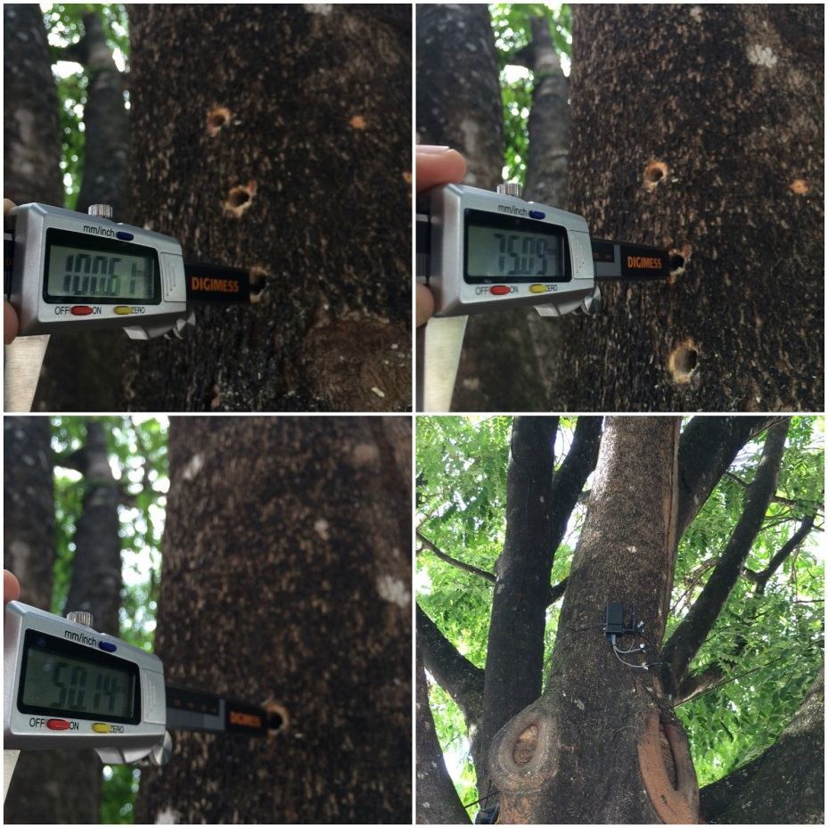

Figure 9. Sensor nodes installation.

As shown in Figure 4, the two Namimote-based sensor nodes (SN1 and SN2) send data within a chosen specific time interval, 30 seconds, to the sink node at the laboratory. The data of the sensor node SNi are composed of four measured temperature levels, as described in Table 1.

Table 1. SNi data description.

|  |  |
| --- | --- |
| **Description** | **Meaning** |
| Ti50 | Temperature at 50mm depth |
| Ti75 | Temperature at 75mm depth |
| Ti100 | Temperature at 100mm depth |
| TiExt | External Temperature |

All received data are stored and analyzed using RSTUDIO, 2015. In the next section, we will show the experimental results detailing the most important remarks.

1. Experimental results

The first experimental results obtained are concerned to the simulation of the signal propagation of both sensor nodes according to the laboratory’s localization. As shown in Figure 10(a) and Figure 10(b), it is possible to observe that the location of the sink node is a place with strength signal from both nodes. This signal propagation was obtained using the software INSITE© and the simulation lasted 36 hours.

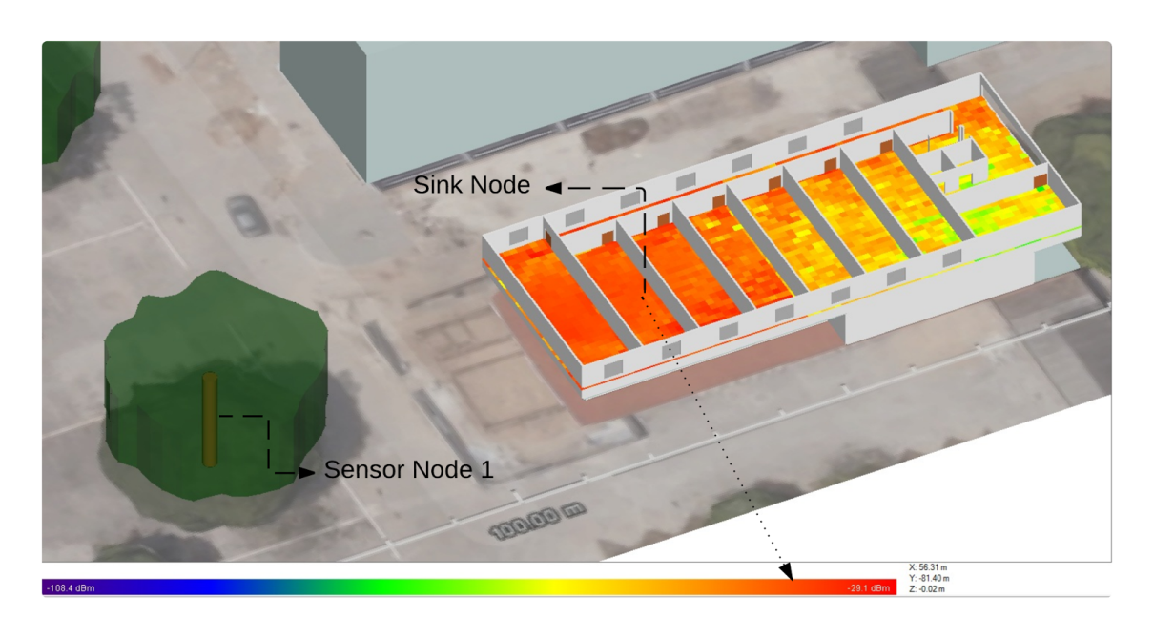

Figure 10. (a) Signal propagation simulation results for SN1.

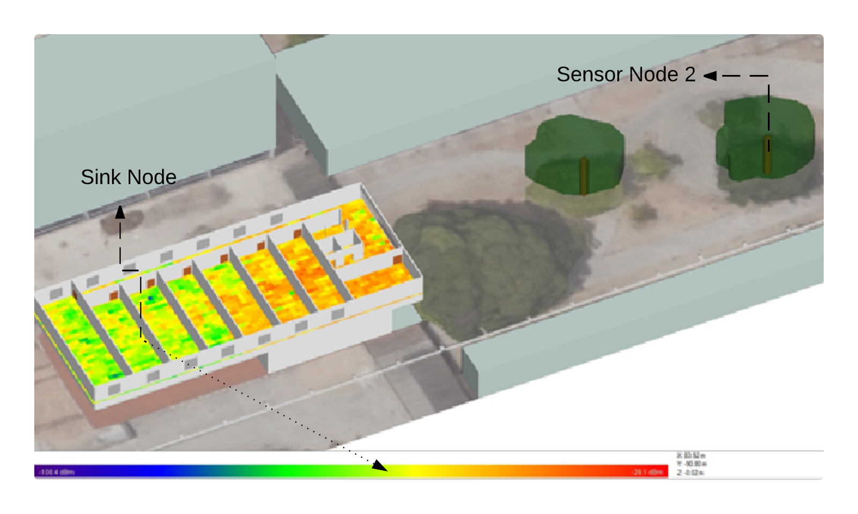

Figure 10. (b) Signal propagation simulation results for SN2.

The next experimental results obtained are concerned to the measured data from sensor nodes. Figure 11 shows the data from the SN1 on January 21, 2016 at 7°08'38.0"S 34°51'02.4"W. As expected, T1Ext > T150 >T175>T1100.

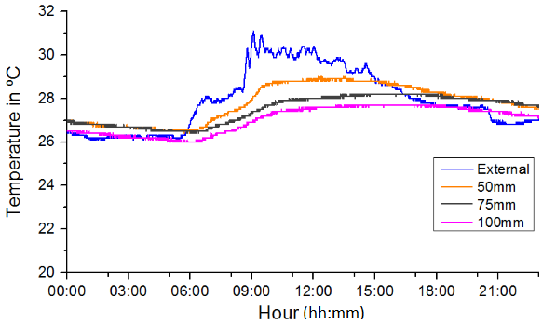

Figure 11. Obtained data from SN1.

Figure 12 shows the obtained data of SN1 considering the period of Jan. 18 to Jan. 24, 2016.

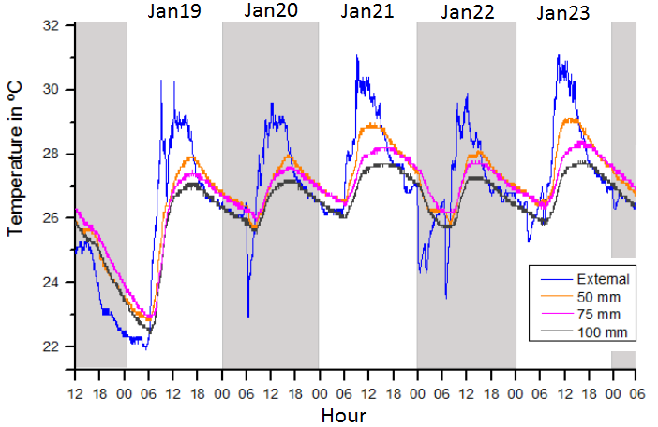

Figure 12. Obtained data from sensor node 1 from Jan. 19 to Jan. 23, 2016.

Figure 13 shows the temperature gradient values (ΔT) from the SN1 considering the period of Jan. 18 to Jan. 24, 2016. As expected, ΔT1Ext-100 > ΔT1Ext-75 >ΔT1Ext-50 where ΔT1Ext-100 = T1Ext - T1100, ΔT1Ext-75 = T1Ext - T175, and ΔT1Ext-50 = T1Ext - T150.

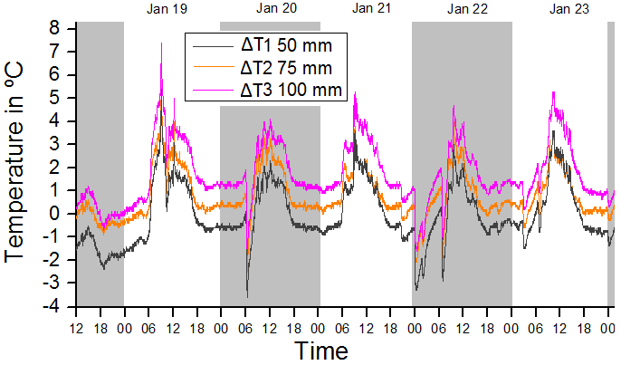

Figure 13. Obtained temperature gradient values (ΔT) from SN1.

Figure 14 shows the data from the SN2 on January 21, 2016 at 7°08'35.6"S 34°50'59.3"W. As expected, T2Ext > T250 >T275>T2100.

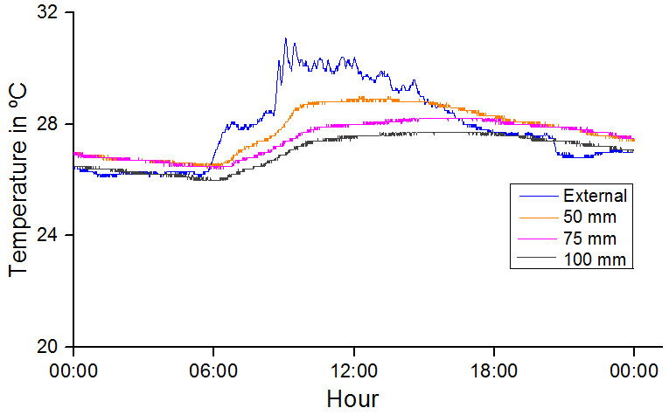

Figure 14. Obtained data from SN2.

Figure 15 shows the obtained data of SN2 considering the period of Jan. 18 to Jan. 24, 2016.

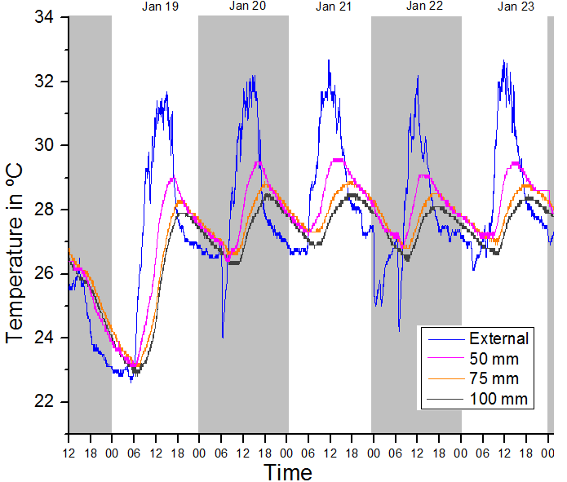

Figure 15. Obtained data from SN2 from Jan. 19 to Jan. 23, 2016.

Figure 16 shows the temperature gradient values (ΔT) from the SN2  considering the period of Jan. 18 to Jan. 24, 2016. As expected, ΔT2Ext-100 > ΔT2Ext-75 >ΔT2Ext-50.

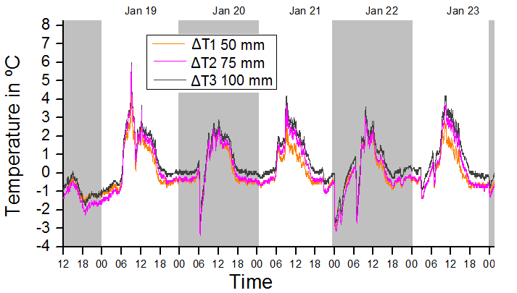

Figure 16. Obtained temperature gradient values (ΔT) from SN2.

One can verify from the experimental results that especially from those of Figure 13 and Figure 16, the values of ΔT vary along the day/night from a positive maximum value (+δ) to a negative maximum value (-δ). This result is very interesting since this indicate that at most part of the day/night energy can be obtained from the trees. Only near midnight that ΔT≈0. This is a remarkable result because, as the Peltier cell is a bidirectional device, a positive voltage (before midnight) or a negative voltage (after midnight) is obtained and a rectifier must be used to harvest adequate voltage. This is different from photovoltaic cells that only work under sunlight.

Also, it can be seen that as deeper the sensor is installed, bigger is ΔT. This result indicates that the depth to install the sensors can be chosen accordingly to the voltage level that is required. However, this depends on the tree trunk diameter limitation.

1. Conclusions and possible future directions

This work described a study on the possibilities of harvesting energy from tree trunks in order to power sensor nodes for environmental monitoring, particularly in wild forests. It was detailed the experimental apparatus employed that was composed of a wireless sensor network based on Namimote nodes and the applicability of our results by the use of Peltier cells to convert temperature gradient into electrical voltage. The experimental results show the viability to harvest thermal energy during the day and during the night while photovoltaic cells  only works under sunlight.

References

Ali, M. Albasha, L. and Qaddoumi, N. RF energy harvesting for autonomous wireless sensor networks. In Design Technology of Integrated Systems in Nanoscale Era (DTIS), 2013 8th International Conference on, pages 78–81, March 2013.

Barako, M. T. Park, W, Marconnet, A. M. Asheghi,  M. and Goodson, K. E. A reliability study with infrared imaging of thermoelectric module under thermal cycling, in Thermal and Thermomechanical Phenomena in Electronic Systems (ITherm), 2012 13th IEEE Intersociety Conference on, May 2012, pp. 86-92.

Baroudi, U. Qureshi, A. Mekid, S. and Bouhraoua, A. Radio frequency energy harvesting characterization: An experimental study. In Trust, Security and Privacy in Computing and Communications (TrustCom), 2012 IEEE 11th International Conference on, pages 1976–1981, June 2012.

Cheng, Yulun and Yang, Longxiang. An Energy-Efficient Transmission Protocol for RNC-Based Cooperative WSNs with Partial Energy Harvesting Nodes. International Journal of Distributed Sensor Networks, vol. 2015, Article ID 937404, 12 pages, 2015. doi:10.1155/2015/937404.

Chong, C. and Kumar, S. Sensor Networks: Evolution, Opportunities, and Challenges. Proceedings of the IEEE, Vol.91(8), pp. 1247-1256, August 2003.

Corke, P. Wark, T. Jurdak, R. Wen Hu, Valencia, P. and Moore, D. Environmental wireless sensor networks. Proceedings of the IEEE, 98(11):1903–1917, Nov 2010.

Freris, N. M. Kowshik,  H. and Kumar, P.R.. Fundamentals of large sensor networks: Connectivity, capacity, clocks, and computation. Proceedings of the IEEE, 98(11):1828–1846, Nov 2010.

Galayko, D.  Pizarro, R. Basset,  P. and Paracha, A.M. AMS modeling of controlled switch for design optimization of capacitive vibration energy harvester. In Behavioral Modeling and Simulation Workshop, 2007. BMAS 2007. IEEE International, pages 115–120, Sept 2007.

Harb, Adnan. Energy harvesting: State-of-the-art. Renewable Energy, 36(10):2641–2654, 2011.

Harmon, Paul J. The Secret World of Trees. West Virginia Wildlife Magazine. Fall 2007.

Helliker, Brent R. and Richter, Suzanna L. Subtropical to boreal convergence of tree-leaf temperatures.  Nature.  Vol 454|24 July 2008| doi:10.1038/nature07031

Ismail, B. I. and Ahmed, W. H. Thermoelectric power generation using waste-heat energy as an alternative green technology. Recent Patents on Electrical Engineering, vol. 2, no. 1, pp. 27-39, 2009.

Kim, Sangkil; Vyas, R. Bito, J. Niotaki, K. Collado, A. Georgiadis, A. and Tentzeris, M.M. Ambient RF energy-harvesting technologies for self-sustainable standalone wireless sensor platforms. Proceedings of the IEEE, 102(11):1649–1666, Nov 2014.

Lan, Shi;  Qilong, Miao and Du, Jinglin. Architecture of wireless sensor networks for environmental monitoring. In Education Technology and Training, 2008. and 2008 International Workshop on Geoscience and Remote Sensing. ETT and GRS 2008. International Workshop on, volume 1, pages 579–582, Dec 2008.

Liang, Ying and Feng, Yongxin. An energy-aware routing algorithm for heterogeneous wireless sensor networks. In Hybrid Intelligent Systems, 2009. HIS ’09. Ninth International Conference on, volume 2, pages 275–278, Aug 2009.

McPherson, J. W. Reliability Physics and Engineering - Time-To-Failure Modeling, 1st ed. United States: Springer US, 2010.

Moraes Junior, T. O. Rodriguez, Y. P. M. and Souza, C. P. Experimental results on magnetic cores for magnetic induction-based energy harvesting. In 19th IMEKO TC4 Symposium and 17th IWADC Workshop Advances in Instrumentation and Sensors Interoperability, pages 625–630, July 2013.

Nayak A. and Stojmenovic, I. Wireless Sensor and Actuator Networks. John Wiley & Sons, New Jersey, USA, 2010.

Nesarajah, M.; Felgner, F.; Frey, G.: Modeling and Simulation of a Thermoelectric Energy Harvesting System for Control Design Purposes. Proceedings of the 16th International Conference on Mechatronics - Mechatronika (ME), IEEE, Brno, Czech Republic, pp. 170-177, Dec. 2014. <DOI: 10.1109/MECHATRONIKA.2014.7018254>.

Nobel, Park S. Physicochemical and Environmental Plant Physiology. URL: https://books.google.com.br/books?id=3wMBwxGIqDIC, 2009 Elsevier Science.

Pekoslawski, B. Krasinski,  P. Siedlecki,  M. and Napieralski, A. Autonomous wireless sensor network for greenhouse environmental conditions monitoring. In Mixed Design of Integrated Circuits and Systems (MIXDES), 2013 Proceedings of the 20th International Conference, pages 503–507, June 2013.

Priya, S. and Inman, D. J. E. Energy Harvesting Technologies, 1st ed. United States: Springer US, 2009.

Ramadass, Y. K. and Chandrakasan, A.P. A battery-less thermoelectric energy harvesting interface circuit with 35 mv startup voltage. Solid-State Circuits, IEEE Journal of, 46(1):333–341, Jan 2011.

REMCOM. 2015. Available at <http://www.remcom.com/wireless-insite>. Accessed on February 2016.

Santos, M.P. Vieira, D.A. Rodriguez, Y.P.M. Souza, C. P. Moraes, T.O. and Freire, R.C.S. Energy harvesting using magnetic induction considering different core materials. In Instrumentation and Measurement Technology Conference (I2MTC) Proceedings, 2014 IEEE International, pages 942–944, May 2014.

Silva F. A. N., Braga M. V., Lampa P. H. D. M., Silva S. M. G., Baiocchi O. R., Yeung K.Y., Barret C. M., LANDOWSKI R., de Carvalho F. B. S. Development of a Wireless Sensor Network for Indoor Environment Using Wireless InSite. in ENCOM - IECOM Annual Meeting in Communications, Networks and Cryptography, Campina Grande, Brazil 2015.

Sudevalayam, S. and Kulkarni, P.. Energy harvesting sensor nodes: Survey and implications. Communications Surveys Tutorials, IEEE, 13(3):443–461, Third 2011.

Tan, Yen Kheng (Ed.), Modeling and Simulation of Thermoelectric Energy Harvesting Processes, Sustainable Energy Harvesting Technologies – Past, Present and Future, 1st ed. United States: InTech, 2011.

Wu, Tianqing and Yang, Hong-Chuan. RF energy harvesting with cooperative beam selection for wireless sensors. Wireless Communications Letters, IEEE, 3(6):585–588, Dec 2014.

Yao, Nan;  Wang, Shaoping, Shang, Yaoxing and Shi, Jian. Reliability of wireless sensor network: Hotspot and critical challenges. In Industrial Informatics (INDIN), 2012 10th IEEE International Conference on, pages 1262–1266, July 2012.

Zhou, Guomo;  Tang, Shaojie;  Lu, Dengsheng;  Liu,  Liang;  Han, Jinsong and Dong, Wei. Wireless Sensor Networks for Agriculture and Forestry. International Journal of Distributed Sensor Networks, vol. 2015, Article ID 845364, 2 pages, 2015. doi:10.1155/2015/845364.